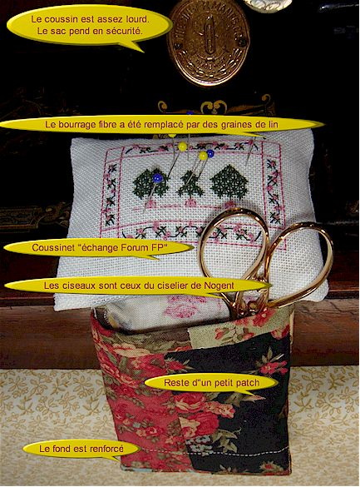

- The cushion is quite heavy. The bag is securely hanged.
- The polyester filling as been replaced by flax seeds.
- The cushion is one of the exchange on the French quilters guild
- These nice scissors are made by a traditional “scissor-man” in Nogent (the place from where came all our French old scissors).
- The bag is made with the left-off another quilt
- The bottom is secured by a double-lined fabric;

